

**Jenny Pitama- Manager Business Development**

**Changes to Kidsfirst Marketing and Promotion**

**Important Information and Actions**

As the early childhood education sector becomes more and more competitive, we are seeing new centres pop up in our kindergarten neighbourhoods every month. In the last ten years 13,500 new spaces have opened in the South Island – 8000 of these are in areas where we operate.

In some areas this has definitely impacted our rolls.  To stay viable and remain open we need to focus on getting our occupancy rates up with more enrolments and through maximum use of child funded hours each day.

As you saw in the January CONNECT, we have begun our “*Better Because*” campaign – simple messages which really focus on our points of difference – on various digital platforms, like Facebook, Trademe and Neighbourly.  We want to create awareness and interest in our kindergartens and ELCs which will lead to engagement – either at a kindergarten/ELC, through Head Office, or on our website. From there we want our families to make a decision to enrol and commit with Kidsfirst. Initial data collection shows that this approach has resulted in 75 more enrolments across our network this year to date than previous years!



**Centralising enquiries**

Capturing these prospective parents/children and getting them either on the kindergarten/ELC wait list or enrolled is paramount – this is the *sale*. Our ads and posts are creating awareness and interest at a personal level, and the “call to action” buttons (*enrol now, join the waitlist, send us a message*) on our website and advertising now take our parents straight to a pre-enrolment form.

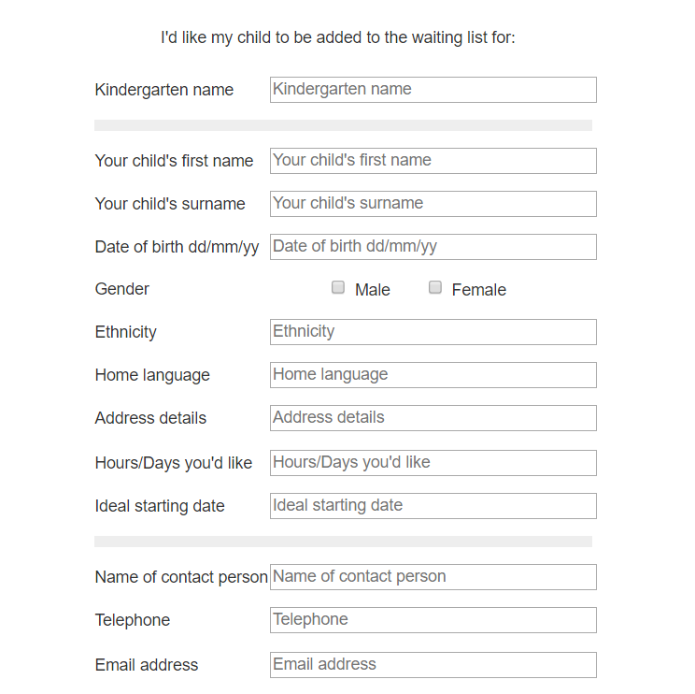

This online form contains all the information we need to waitlist the child – and it all comes to head office. In the past parents had to download and complete the first four pages of the enrolment form and they often did not send it back – we lost the sale.

**What does this mean for you?**

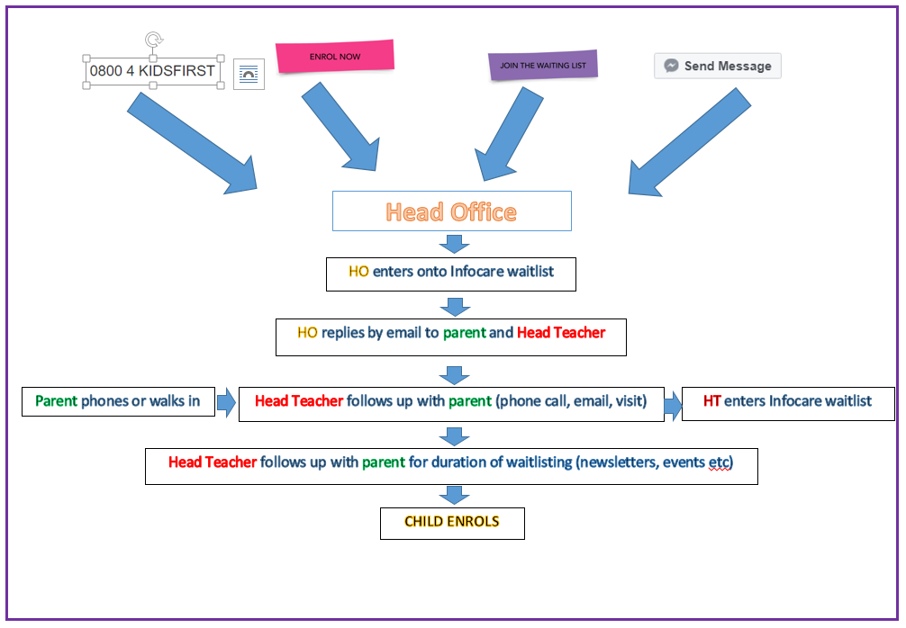

Centralising the responses from all web-based and 0800 enquiries to Head Office will ensure our prospective parents/children are officially waitlisted, it’s helping us to get them to commit. There are hundreds of spaces available in other centres across Christchurch, and families will enrol elsewhere if we don’t offer an immediate response – whether this is a spot on the wait list or a start date.

So – we respond to the initial request, and enter the child on your Infocare wait list – then we reply to the parent and copy your Head Teacher in. We know that once you have followed up and invited our families to visit, you are able to tell them all about why Kindergarten is *better because* -“closing the sale”.   It’s getting them in that we need to concentrate on, and so we’re taking most of the initial enquiries away from the kindergartens and directing them through Head Office so that you are not trying to answer queries and talk to parents during operating hours – it’s never a good thing for a customer to think we’re too busy – even when we really are!

Even if you don’t have spaces right now, once we have the child on the waitlist we can continue to engage with the parents until a space becomes available. This continued engagement is a core part of your role and will help to establish a relationship with the family. Things like sending out your Report to the Community at the end of term, or inviting waitlisted families to kindergarten events. Or just a quick phone call to give them an update on an expected start date. Why don’t you offer them the afternoon spaces for an immediate start as a way of getting them in – even if they asked for mornings?

**Using Infocare to manage your waitlist**

It is critically important that Infocare is used to manage and hold all wait list data. If we don’t have an overall picture of our long term viability, it puts us at risk. Having accurate wait lists gives us a baseline of information about who eventually enrols, and if not, we can find out *why not* – and we intend to do so. We pull reports off Infocare on a regular basis – and sometimes decisions on staffing are made at Head Office based on this information and may affect your kindergarten. If the information is not accurate and up to date the wrong decision might be made.

**If you are currently running a spreadsheet or a paper-based list, it is expected that you will transfer it to Infocare before the 4th of May. All children, regardless of age should be entered into Infocare. If you do not have time to do this please call Chandra and she will arrange to have the data put in from Head Office.**

Chandra has added an **extra step into your infocare data entry process** – a new drop down box that you can use to indicate when a family have been offered a space but have ‘deferred’. This drop down list is found on the child’s ‘Modify’ page under ‘Category’ –just click here and a list of defer times appear. After you have offered a child a place on your roll and if the family decline the place then use these ‘Defer’ times to keep track and keep Head Office informed. Again, this is important when we are pulling reports off Infocare so we can see why a child has not started yet.

**For Children aged 2yrs to school age**

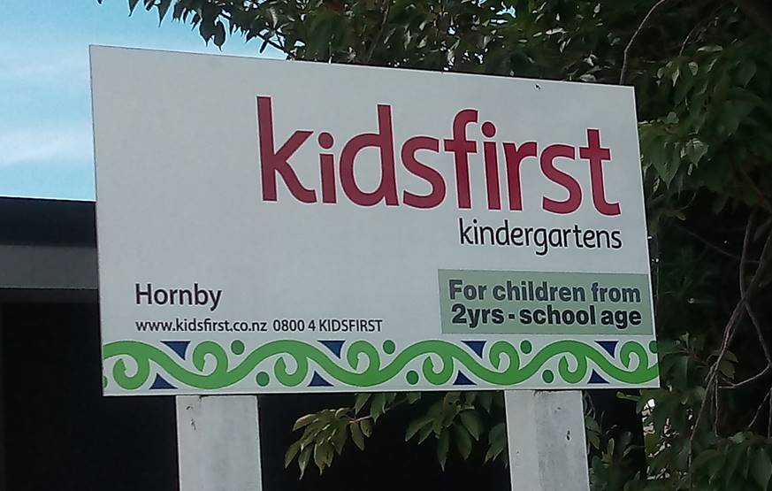

We have some key sales messages which you have seen on the website and in our advertising before: 30 hours Free, 100% qualified teachers, #better because, etc.  Added to this we need to change the general perception that we only take three and four year olds – based on past practices in New Zealand kindergartens. I will be coming out to your kindergarten in term two (Canterbury) and updating your signage (only those with the pictured sign) with a new sticker, and having a chat to you about marketing and promotions in general.

You will be expected to manage your waitlist according to usual practice by prioritising children with the greatest need, the oldest children etc. But the message is clear:  If you have hours/days available they should be filled from your waitlist regardless of age - immediately. If we continue to turn away two year olds we are inevitably going to lose these potential enrolments to our competitors and away from kindergarten for good.

**Your Kidsfirst Webpage**

Work is being done on updating our website. There have already been a few changes, such as the *enrol now* and *join the waitlist* buttons, and the addition of a new email address: [betterbecause@kidsfirst.org.nz](mailto:betterbecause@kidsfirst.org.nz). This email address now appears above your kindergarten email address as the first port of call for enrolment and waitlisting enquiries – and once again it comes straight to Head Office.

Currently on each kindergarten’s page there is a list of routines, mat times, kai times etc. – information better given out in an enrolment pack. Some of the info is also well out of date.

We’ll be updating each webpage with a short, succinct description of what makes your kindergarten unique – removing old and unnecessary information. To do this, **please respond to my email** (10.04.2018) with your answers to a very short list of questions which we can then turn into your webpage information. Thanks to those who have already done so – we’ve had some really creative descriptions!

**Flags**

I have ordered new flags, they will arrive sometime in term two. I’ll be calling you to talk about what you need very soon. We think these are one of our best sales tools, you can see them from a great distance and for anyone new to your neighbourhood it’s important that we are visible.

**If you have flags but you don’t use them**, firstly I’d like to know why? And secondly I’d like them back thank you very much!

**Footpath Signs**

We have recently purchased 10 rolling footpath signs. These are a great sales tool for kindergartens that are in back sections, or off the main roads. We’ve deliberately kept them generic, and we’ll be trialling them in kindergartens identified by your Education Managers. We can move them around as needed



I will be contacting those kindergartens and bringing the signs out very soon. We have arrows to stick on to denote the direction of the kindergarten from wherever the sign is placed.

There needs to be a commitment from the kindergartens using the signs, as they will need to be put out and taken in each day. Shirley Kindergarten has managed their sign by getting a parent to take the sign out after she drops her child off each day, and then she brings it in when she picks up. Or you could drive past and put it in your boot each day – it’s not too big.

Thanks to everyone for your ongoing commitment to keeping our rolls and waitlists full. If you’ve got any great ideas give me a call or email me anytime.

Ngā mihi nui

Jenny Pitama

Manager Business Development

Kidsfirst Kindergartens